**Development times:** (figures bit blurry will make sure not on final piece)

* **Egg to pupae**
* Figure 1(A)
* **Graph suggests:**
* starch on starch fastest egg to pupation time
* longterm ASG on starch compared to ASG delays pupation by a small amount – suggests starch line adapted to starch diet
* longterm Starch on ASG – delays pupation
* suggests no difference between sexes
* Graphical user interface, text, application, email

  Description automatically generated**Poisson model:**
* No effects of random variables
* Males develop to pupae faster than females (Pr(>|z|) = 0.5305, SE = 0.008)
* Longterm diet starch slightly increases time to pupation (Pr(>|z|) = 0.8270, SE = 0.005)
* No significant effect of larval diet starch
* No significant interaction between larval starch diet and longterm starch diet????????????? --- weird because graph shows clearly that StarchStarch is faster to pupate????????
* **Pupae to eclosed**
* Fig 1(B)
* **Graph suggests:**
* No difference between sexes
* Starch on Starch ecloses maybe slighlty earlier than all other diets which show no differences
* **Graphical user interface, application

  Description automatically generatedPoisson model:**
* No effects of random factors
* Males develop from pupae to eclosion significantly faster than females (Pr(>|z|) = 0.352, SE = 0.008)
* Longterm starch diet significantly reduces pupation to eclosion time (Pr(>|z|) = 0.909, SE = 0.012)
* Larval starch diet also significantly reduced pupation to eclosion time (Pr(>|z|) = 0.735, SE = 0.011)
* Longterm starch flies on starch food develop the quickest, and quicker than would be expected and hence show an interaction between their longterm and larval food (Pr(>|z|) = 0.217, SE = 0.017).
* Interaction - Suggests longterm starch flies have adapted to starch diet
* Suggests immediate diet and longterm diet have an effect on pupation to eclosion time
* **Egg to eclosion**
* Fig 1(C)
* **Graph suggests:**
* Maybe males develop slightly quicker to eclosion than females?
* Starch on starch is faster to develop
* ASG on starch is lowest to develop
* Larval Starch diet is negative to longterm ASG lines’ development time, but longterm starch has adapted to diet
* **A screenshot of a computer

  Description automatically generated with medium confidencePoisson model:**
* No effect of random variables
* Males develop from egg to eclosion significantly faster than females (Pr(>|z|) = 0.258, SE = 0.006)
* Larval starch diet increases development time (Pr(>|z|) = 0.166, SE = 0.008)
* Longterm starch diet increases development time (Pr(>|z|) = 0.902, SE = 0.013)
* No significant interaction between longterm starch and larval starch diet???? Weird coz is clearly shown on graph that Starch on Starch develops quickest???
* Chart, box and whisker chart

  Description automatically generated**Eclosed to first egg laying**
* **Eclosion to first egg laying**
* Cage data
* Fig2(A)
* Graph suggests:
* ASG on ASG – egg-lays fastest
* ASG on starch – delays egg laying
* Starch on starch – slightly slower than ASG on starch
* Starch on ASG – slowest – longterm starch lines adapted to diet
* Graphical user interface, application

  Description automatically generatedPoisson model:
* No random effects
* ASG on ASG has shortest eclosion to egg-laying time
* Longterm starch diet increase eclosion to egg laying time (Pr(>|z|) = 0.424, SE = 0.269)
* Larval starch diet increases eclosion to egg laying time (Pr(>|z|) = 0.782, SE = 0.278)
* Interaction is shown between longterm + larval starch diet, reduces the development time that that expected (Pr(>|z|) = 0.652, SE = 0.386)
* Order of develop (fastest to slowest): ASG,ASG ; ASG,Starch ; Starch,Starch ; Starch,ASG
* **Egg to first egg laying**
* Overall development timeline (only cage data, therefore only from 1 pupation date for each)
* 2(B)
* Graph suggests:
* Starch on starch overall quickest
* Own diet allows quickest development
* **Graphical user interface, application

  Description automatically generatedPoisson model:**
* No random effects
* Larval starch diet – increase development time (Pr(>|z|) = 0.806, SE = 0.098)
* Longterm starch diet – increases development time (Pr(>|z|) = 0.806, SE = 0.098)
* Large interaction between larval+longterm starch diet (Pr(>|z|) = 0.585, SE = 0.142) - Shows adapted to diet
* Overall development times fastest to slowest: Starch,Starch ; ASG, ASG ; then ASG,Starch and Starch ASG have same development time.
* Therefore, better on own diet, longterm starch lines adapted to low nutrient diet.

**Pupae to adult survival**

* Binomial model
* Haven’t managed graph yet
* Larval diet+ long term diet as fixed effects
* Well, plate, fly line and egg collection date as random effectsA screenshot of a computer

  Description automatically generated with medium confidence 🡪 n/a effect of random factors
* Chart, box and whisker chart

  Description automatically generatedQQ plot and Levene’s test show - Residuals fit and high homogeneity of variance
* No significant effect of larval diet and no significant interaction between larval diet and long-term diet (as P-value <0.05)
* Long term starch diet has small decrease on survival (p-value = 0.801, SE = 0.32691)
* A screenshot of a computer

  Description automatically generated with medium confidenceemmeans of binomial model:
* Probability of eclosing (longterm diet, larval diet):

ASG,ASG - 0.932

Starch ASG, - 0.927

ASG, Starch - 0.886

Starch Starch - 0.938

* all contrasts between diets significant except for ASGASG - ASG-Starch
* suggests starch on starch has highest pupae to adult survival rate then ASG ASG
* highest survival on own diets
* the non-significance between ASG on own diet and on starch suggests larval starch diet doesn't have negative affect on survival but larval ASG diet does
* **Body size and egg size and egg number:**
* 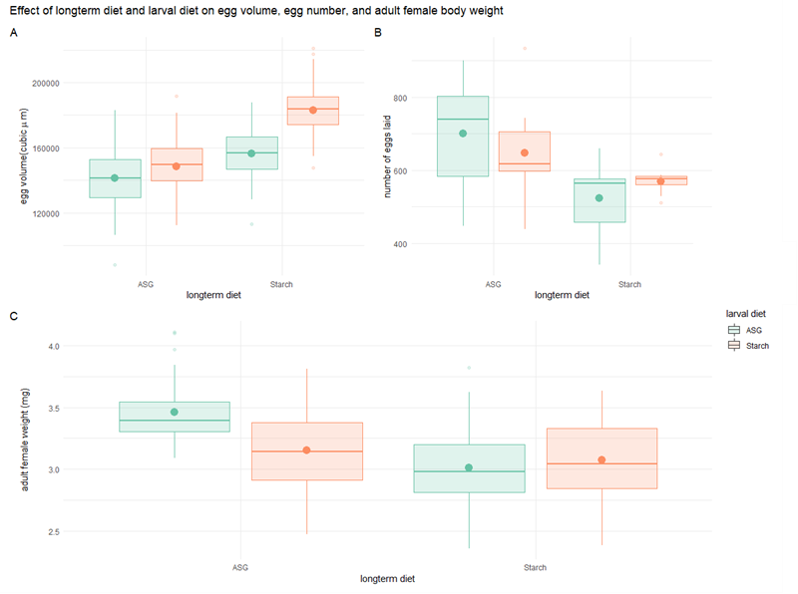Figure – points – means generated from linear model
* **Egg volume:**
* Fig4(A)
* Graph suggests:
* ASG on ASG smallest
* Longterm ASG on starch – increases egg size
* Starch on Starch largest
* Longterm Starch on ASG – decreases egg size but still larger than both longterm ASG
* Suggests starch larval diet increases egg size, and that starch has adapted to this diet.
* **Graphical user interface, text, application, email

  Description automatically generatedLinear model:**
* Residuals fit QQ plot and high homogeneity of variance shown by Levene’s test
* Shows no significant difference between diets
* **Graphical user interface, text, application, email

  Description automatically generatedEmmeans of linear model**
* Starch has highest mean but isn’t significantly larger
* **Female body weight:**
* Fig4(C)
* Graph suggests
* ASG on ASG heaviest
* Longterm ASG when on starch decreases weight
* Longterm Starch on ASG lightest
* Longterm starch on starch heavier than when placed on larval ASG – adapted to longterm diet
* **Graphical user interface, text, application

  Description automatically generated**Both best on own longterm diet
* **Linear model:**
* Residuals fit QQ plot and high homogeneity of variance shown by Levene’s test
* No significant difference between weights
* Emmeans from linear model:
* Graphical user interface, text, application

  Description automatically generatedASG ASG have highest mean weight but it isn’t significantly different
* Biggest flies lay the smallest eggs??
* **Egg number:**
* Fig4(B)
* Graph suggests:
* ASG on ASG lays most eggs
* Longterm ASG on starch decreases egg number
* Longterm Starch on ASG lays least eggs
* Graphical user interface

  Description automatically generatedLongterm Starch on starch lays more eggs than on ASG
* **Linear model**
* Starch Larval diet decreases egg number by ~53.11 (Pr(>|t|) = 0.30, SE = 49.80, df = 27.07)
* Long term starch diet has no significant effect on egg number (Pr(>|t|) = 0.04, SE = 73.022, df = 6.67)
* When Both larval and longterm starch diet Significant interaction is show, increasing egg count from expected value for both when both diets is starch by ~99.757 eggs (Pr(>|t|) = 0.18, SE = 71.62, df = 27.14)
* Graphical user interface

  Description automatically generated**emmeans of linear model**
* Mean number of eggs for ASG on ASG is 700 (SE = 51.6, df = 6.57), which when placed on starch decreases by ~53.1 eggs (p = 0.7123, SE = 49.8, df = 27.00)
* Mean number of eggs for Starch on Starch is 570 (SE = 53.3, df = 7.33), which increases by ~46.6 eggs when placed on ASG larval diet (p = 0.8024, SE = 51.6, df = 27.15)